52.Take the sample application nodejs and build it- > deploy to s3.

-take the application

-build application

-deploy the application to s3.

shell script to do the activity.

Shell script of the node js application

Save the script file as app.js

To execute permission to the script.

Chmod +x app.js

To run script:

./app.js

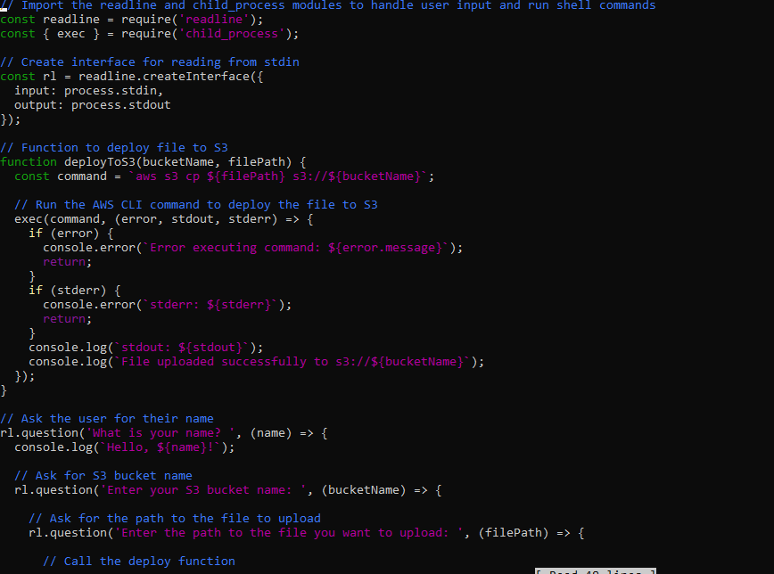

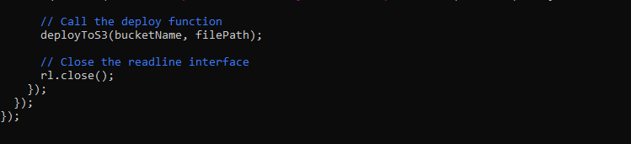

Output:

